Crucial conversations are interactions that happen to everyone.
They are day-to-day conversations that affect your life.

Some of the most common instances are critiquing a colleague’s work, talking to a team member who isn’t keeping commitments, talking to a coworker who refuses to listen or behaves in some other inappropriate way. If the person becomes rude or belligerent and a crucial conversation must take place – remember that:

In a crucial conversation opinions vary, the stakes are high, and emotions run strong.

Most of these conversations involve the way people behave or perform.
To enhance your success -
- Don’t let your own apprehension stand in the way
- Prepare rather than confront without a plan
- The goal is to achieve a positive outcome for both parties
- Set a clear goal for what you want to focus on during the conversation
- Consider the other person’s background and how they best receive comments
- Pick the best time and location
- Arrive relaxed and begin with positive thoughts and appreciate the opportunity to talk
- Communicate your hopes for the conversation, be specific and focus on your goal
- Try not to get sidetracked with other topics or emotional responses
- Discuss your feelings and why the situation is important to you and how it is impacting you and others
- Listen to the other party’s perspective
- Take a stance of curiosity rather than becoming defensive
- Keep in mind possible solutions and try to be flexible in finding ways to fix the problem
- If there is some agreement make sure there is a shared understanding
(https://www.youtube.com/watch?v=WGcI6RWCohk)

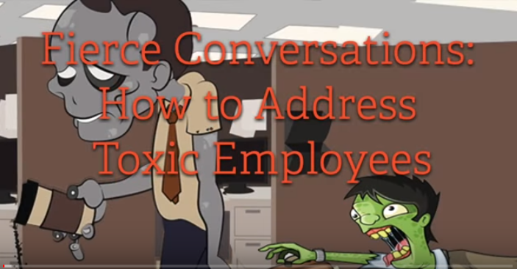

During the crucial conversation, when confronted with an opposing, negative or incomprehensible comment - Respond with one of the following:

- That’s interesting, tell me more.
- That’s interesting, why would you say that?
- That’s interesting, why would you do that?
- That’s interesting, why would you ask that?

Monitor the dynamic of the team discussion and do all you can to make people safe. In the absence of safety, people may turn to silence or violence – neither will resolve the differences between people.

Silence may present itself through masking, avoiding or withdrawing.

Violence may present itself through controlling, labelling or attacking.

