Making Change Happen

Open the file folder, then open Change simulations
If at any time an error message pops up, ignore it. If you are asked for a serial number type in 22145448
Choose Making Change Happen, then Making Change Program
Select the icon that looks like an old fashioned movie projector
The files with the people descriptions and the strategies have already been printed for you.
You may review the Overview and Your Task if you wish to understand the circumstances and goal of the game are OR you can proceed to play the game.
Your goal is to move as many people into the routine use columns. Black space are freebies. Wise choices in strategies will build up bennies. The combination of routine users and bennies determines your level as a change agent. level requires about 4000 bennies. Apprentice, Novice, Manager, Leader, Expert, or Master. Master
When you choose Start Simulation the following screen will open.

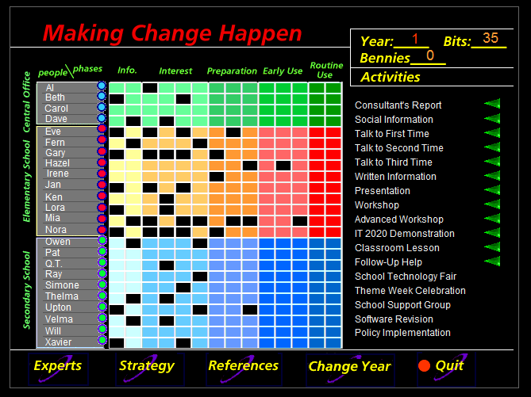

Notice that you are in Year One of a three-year game. You have 35 bits which you use to finance any strategy that you choose to implement during the first year. The available strategies have a green triangle used to select them. Follow the directions and make notes on the outcomes of each strategy.
If you wish to benefit from the social information you must first choose it as a strategy.
These strategies are explained in the handout. At any time you can check your strategies and print them out. You may consult experts if you wish to do so.
Once you expend all of your bits you will select ‘Change Year’ to access next year’s resources and then continue playing. Once you have expended all the bits for the third year you will quit.
When you quit you will be given your performance level. You should either print or take a photograph of this and submit it to get your grade.
Apprentice B-
Novice B
Manager B+
Leader A-
Expert A
Master A+

