A Professional Learning Community is composed of collaborative teams who work interdependently to achieve common goals linked to the purpose of learning.
Teams are the ‘engines’ of PLC operations.
Trust is the ‘lubricant’ that keeps the engine running.
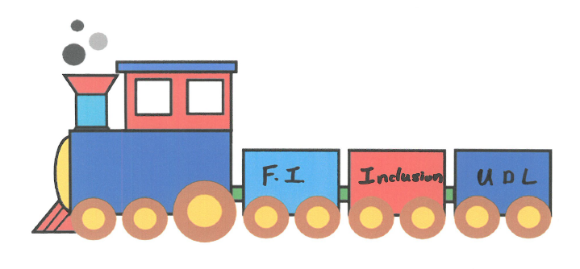
Working in effective teams and building trust among team members is essential.

Team and Trust Building
Professional Learning Session Jun 11, 2018

Teams are the ‘driving forces’ of PLC operations
Interdependent teamwork is what learning communities are all about. Productivity, performance, and innovation result from joint action, not just individual efforts and behaviour.

Trust is the basis for choosing new directions. Depending upon one another, supporting each other, and letting go of control can be daunting. Collaboration, shared decision making, and mutual responsibility require us to build relationships and take risks.

Building trust and developing effective teams requires a focus on both the
tasks and the processes we use to achieve them.

Team – a group of people working interdependently to achieve a common goal for which members are held mutually accountable. A collection of teachers does not truly become a team until they must rely upon one another (and need one another) to accomplish a goal that none of them could achieve individually.
Those who develop systematic practices do not hope things happen a certain way: they create specific structures to ensure certain steps are taken.
The reason teachers are organized into teams and provided time to work together, the reason they are asked to focus on certain topics and complete specific tasks, is so when they return to their classrooms they will possess and utilize an expanded repertoire of skills, strategies, materials, and ideas in order to impact student achievement in a positive way.

- Task-focused Essentials for effective team meetings
- Time/Priority
Team work is a commitment. It’s more than showing up; it demands active participation.
- Purpose
A meeting should never be called unless there is a purpose. The purpose should be goal related.
- Agenda
Meetings consume precious time. An agenda focuses our actions and enhances results. When the time is up, the meeting is over.
- Minutes
Records of what was discussed, decisions that were made, and members’ responsibilities in preparation for the next meeting ensure team productivity.
- Follow up
Post-meeting follow up reinforces decisions, promotes reflection, and encourages active participation by team members.

- Relationship-focused Essentials for effective team meetings
- Norms
Team norms are not intended to serve as rules, but rather as commitments. When done well, norms can help establish the trust, openness, commitment, and accountability that move teams from trivial to substantive efforts.
Expectations for individuals’ participation cannot be simply assumed. Teams must identify and commit to team generated expectation norms. This process must be revisited each time a new member joins the team.
- Protocols
Protocols are anticipations and responses to individuals or joint breaches of the team norms.
The most effective anticipation is the repeating of the norms at the beginning of each meeting. Other effective protocols are questions starting with: “So how are we doing with …?”
- Interdependent roles
The identification of team member roles reinforces appropriate team processes. Teams can choose to either rotate roles, or to establish long term roles. Interdependence processes should focus on results even if everyone does not agree. If we want everyone to agree before we can act we give every member of the team the power to veto. This subjects us to constant inaction and a state of status quo.

- Skills for effective team meetings
- Active listening
One of the most difficult habits to develop is to listen actively when others speak. We often hear the speakers first point and automatically start processing our beliefs, thoughts, and past experiences. Sometimes we even interrupt the speaker to comment – before they are actually finished what they are saying. This can lead to respect issues that can lead to a breakdown in team collaboration and even erode trust among team members. One way to enhance listening is to regulate speaking (indigenous culture’s talking stick). An even better way is to practice active listening as a team activity.
- Balancing Inquiry and Advocacy
The ultimate goal is to participate without monopolizing the discussion. One skill that enhances collaboration is to ensure members inquire more than they advocate. (Read the Ross Roberts article & discuss some key points.)

- Consensus decision making
Teams must come to agreement before they can plan for future action. The most productive ways to do so is through the consensus decision making process. This will be dealt with in another PL session but the definition of consensus can give us a prelude and I refer you to the chapter on consensus and conflict in the Solution Tree text “Learning by Doing”.

Consensus is achieved when all points of view have been heard and the will of the team is evident even to those who most oppose it.
- Connect the session to the School Instrument
- Examine the School Report data related to the topics
- Use these items to focus the purpose of the session

- Personality – Developing trust by Understanding Personality
- Trust Activities
- Photo activity – Trust as a Mental Model
- Identifying Reasons for Relational Trust
- Surfacing Trust Relationships
- Credibility Questionnaire

