Elaboration is a strategy used to organize memories. When we elaborate we associate new pieces of information with other information that has already been recorded in our long term memory.

One example is mnemonics, which are verbal, visual or auditory associations with other, easy to remember constructs.

Verbal Examples:

- How do you remember the order of the colors in the rainbow?

- What are the notes that are on the lines of a musical composition? What are the notes for the spaces?

- If super man helps every one, How many great lakes are there and what are their names?
- You can remember the eight digit value of the mathematics symbol $π$ if you ask; “May I have a large container of coffee?”

- If you don’t have a calendar, how do you remember the number of days in each month?

- How do you know which spelling is correct – receive OR receive ?

- Does a red sky as the sun sets mean tomorrow will be good or bad weather?
Visual Example:

Acrostic Example:

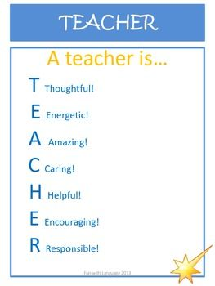

Create an acrostic that could be used to remember the aspects of a seminar for this course.

Learning with Seminars
A Seminar is
S -
E -
M -
I -
N -
A -
R -

