The Speaking Brain

Opening

Video on Language - The importance of language
http://bg3.nationalgeographic.com/episode/13/ - 1:27

Choose one of these statements and discuss it with a partner. What do you thing Silva means? - 10-15 min

- Language re-programmed the software of the brain.
- Language turned a feral mind into a tool that could think with purpose and deliberation.
- Language is a tool that allows the mind to talk to itself.
- Language was the first singularity for humans.
- Language enables us to discuss and decide what we wish to become.
- Language is the way in which the cosmos knows itself.
- Language impregnates the world with meaning

WRITE yourself a few notes and then SAY your ideas to the class.

How does the brain enable us to share and learn in this activity?

http://thebrain.mcgill.ca/flash/d/d_10/d_10_cr/d_10_cr_lan/d_10_cr_lan.html reference site

Left Brain Language Processes – Verbal Communication
20 min
How does the brain process language?

There are actually regions of the brain that are responsible for human language. Not all animals have developed these regions

The combination of these regions is a structure known as the language loop. In simple terms there are three regions.

Broca’s area – speaking language

Wernicke’s area – understanding language

Motor cortex – M1 is used to form words with our mouth
 | 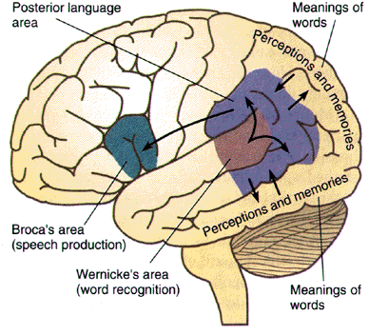
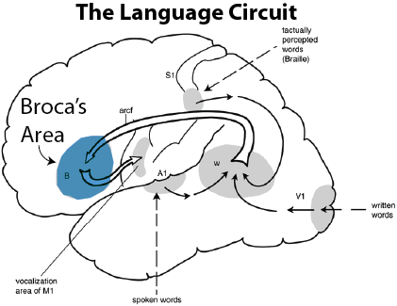 |  |  | In the left hemisphere of the brain, there is a neural loop that is involved both in understanding and producing spoken language. At the frontal end of this loop lies Broca's area, which is usually associated with the production of language, or language outputs.
At the other end (superior posterior temporal lobe), lies Wernicke's area, which is associated with the processing of words that we hear being spoken, or language inputs. |  | 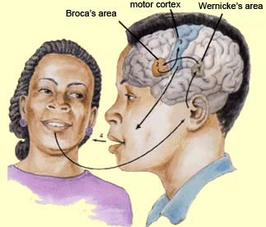
Broca's area and Wernicke's area are connected by a large bundle of nerve fibres called the arcuate fasciculus This loop is also found at the same location in deaf persons who use sign language. This loop would therefore not appear to be specific to heard or spoken language, but rather to be more broadly associated with whatever the individual’s primary language modality happens to be.

Bi-Lateral Language – communicating with both sides of our brains. In the great majority of people:
The left hemisphere that formulates and understands the meaning of words and sentences
The right hemisphere interprets the emotional connotation of these words.

How does your brain interpret sensory stimuli?

Right Brain – Left Brain test
http://www.heraldsun.com.au/news/right-brain-v-left-brain/story-e6frf7jo-1111114603615

What did you see and what do you think it means? 5 min
Interesting lateralization sites http://capone.mtsu.edu/studskl/hd/hemispheric_dominance.html
http://capone.mtsu.edu/studskl/hd/LRBrain.html#Verbal

Right Brain Language Processes – Non-verbal Communication
5 min
Physical appearance, the way they dress, the way they carry themselves, and their general attitude all form a context that lends a particular coloration to a person’s verbal messages. Next, the particular position of their bodies during conversation, the way their eyes move, the gestures they make, and the ways they mimic each other will also impart a certain emotional charge to what they say. There is also what is often called the music of language—the variations in tone, rhythm, and inflection that alter the meanings of words.
When we are talking about language, it is therefore useful to distinguish between two different verbal language processes – ones that denotes the literal meaning of the words - and another, everything that surrounds these words and gives them a particular connotation. It is important to focus on the combination of language processes: the message that is perceived never depends solely on what is said (Left Hemisphere), but always on how it is said as well (Right Hemisphere).

Brain Lateralization
http://www.slideshare.net/StarHolder/relationship-between-brain-and-language-learning-7574755
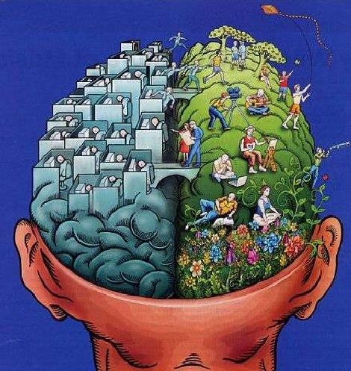
Research seems to indicate that while brain hemispheres may have developed with some specializations, much of what the brain does, requires a balance between these hemispherical specializations. Caetextia is the term used for the condition caused by an imbalance between brain hemispheres. In language one form of this imbalance is referred to as contextual blindness. Since the right hemisphere of the brain regulates creativity, non-verbal learning, attention, and socially appropriate behavior, a child with decreased right brain activity may have trouble reading body language. We believe this may be the cause for behaviours studied by Hans Asperger. Asperger behaviours are traditionally found in left brain dominant children and present as literal, logical, analytical reactions with difficulties in communication and empathy because of a severely diminished ability to think contextually.

Reading body language – quick quiz reading faces – answers provided second step.

http://www.youramazingbrain.org/testyourself/#
http://www.youramazingbrain.org/asp/signup.asp?surveyname=bodylanguage3 5 min

Impact on teaching – Case Study 5 min

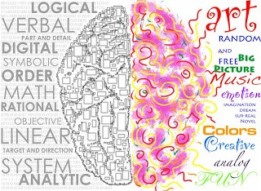

If you can read context, it seems like the most natural thing in the world. You might be talking to Maggie about something, for example, but another part of your attention is aware that Jill is listening as well and could read implications into what you are saying that you didn’t intend. So, straight away, because you have this awareness, you are able to alter the way you speak and detach attention from different objects to take into account Jill’s possible reactions too. When you can do this easily, it is difficult to imagine not being able to do it. But caetextic people can’t. As a consequence, they also have difficulties understanding complex metaphors.

How would this impact the way an English teachers teaches?

Prosody – this term is used to explain how when combined with body language even the simplest sound can be considered language. Prosody is the pattern of stress and intonation a speaker uses to communicate. The following video clip shows how even a baby who has a single word vocabulary can use it to communicate.

http://channel.nationalgeographic.com/brain-games/videos/talking-without-words/ 1:40

Discussion – Are the twins using language to communicate? 5 min
Sign Language

Language need not be oral. The language loop that our brain uses to communicate verbally is the same one that deaf people use to communicate using sign language.

http://time.com/4101501/starbucks-deaf-sign-language-barista-customer/ 1:22

Discussion – 5 min

The American Sign Language can take two forms. The first uses letters to construct words while the second communicates complete words with a single sign or strings together signs to say phrases.
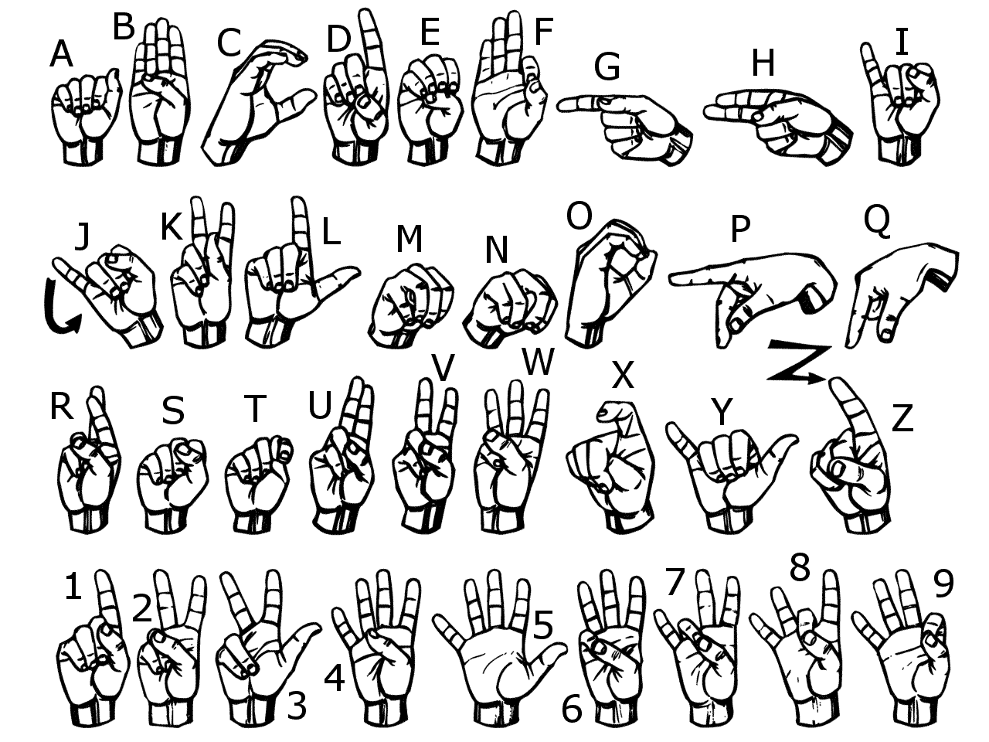

Sign language Single Symbols activity 10-15 min
When do babies start talking?

Handout – Development of Language

Discussion 5 min

Maybe babies can talk earlier if you teach them sign language
Whitney clip:

http://www.babysignlanguage.com/basics/ 1:16

Teaching your baby to talk acrostic: 1:12

F – fun
R – repetition
E – encourage
E – expand

http://www.start-american-sign-language.com/basic-words-in-sign-language.html

Choose a partner and open the website above. Scroll down to you video clip section. Examine the possible words and phrases that you can learn and then construct a brief conversation with your partner. 10:00

As you learn sign language you are programming your language loop in much the same way as you did as a toddler when you first talked. Did the process require both sides of your brain?

Discussion 5 – 10 min

Research Findings for Teachers to Consider

- The acquisition and refinement of speech and language is ongoing until early adulthood.
- School-age children do not have fully developed language systems.
- Children are less efficient language processors than adults.
- Gender differences in language processing have been observed.
- Boys may have more difficulty with verbal expression, and how information is presented may make a greater difference in their ability to learn.
- The brain learns a second language most easily before school age.
- During school years, children’s brains continue to mature and develop with both age and new experiences with language.
- Children may not be able to coordinate ‘listening to language’ and ‘writing language’.
- Simply because a child can behaviourally perform a task does not mean that the brain is efficiently performing that task.
- Language skills can vary widely in groups of same-age children.
- Spoken language is not the only means to determine whether a child understands a concept.

